ADD NEW Staff to Staff Page (Pre-Add)

ADD NEW Staff to Staff Page (Post-Add)

BROWSE Staff Page

SEARCH Staff in Staff Page (Pre-Search)

SEARCH Staff in Staff Page (Post-Search)

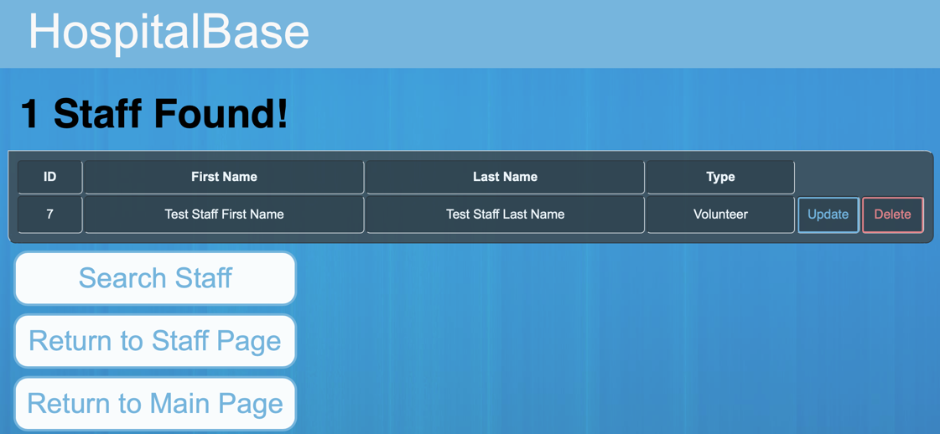

UPDATE Staff in Staff Page (Pre-Update)

UPDATE Staff in Staff Page (During-Update)

UPDATE Staff in Staff Page (Post-Update)

Delete Staff From Staff Page

